EIP landing page for EIP team

1. Once user login to Maybank sandbox, users can see variety of EIP services
2. To request new API project, click EIP section and click API project list

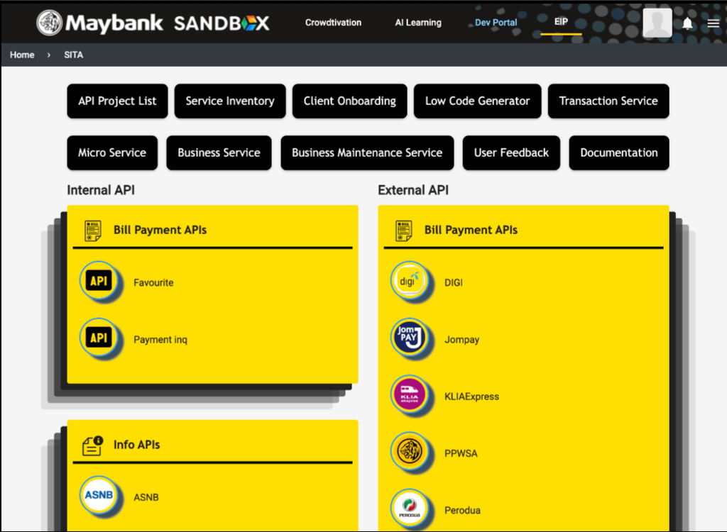

Which will direct you to EIP list.

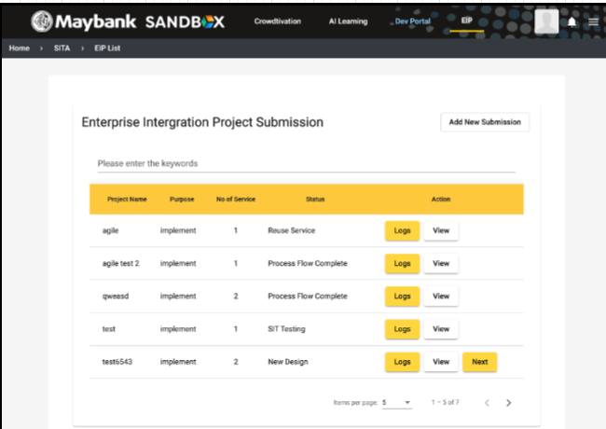

1. Users click ‘add new submission’ then will come to EIP submission page. Users need to fill up details needed and submit.

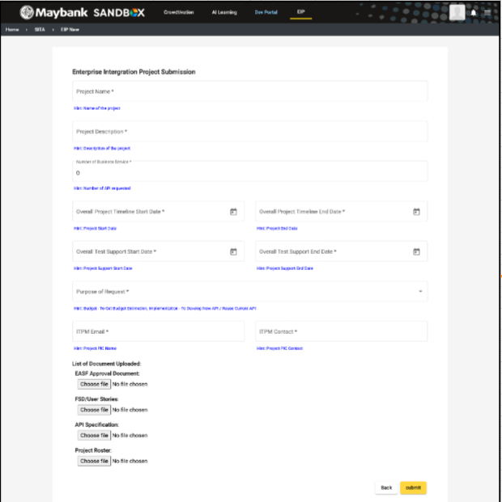

1. After that user will redirect to the submitted list, where user is able to view the details that had key in (also able to view the request had been approved or rejected)

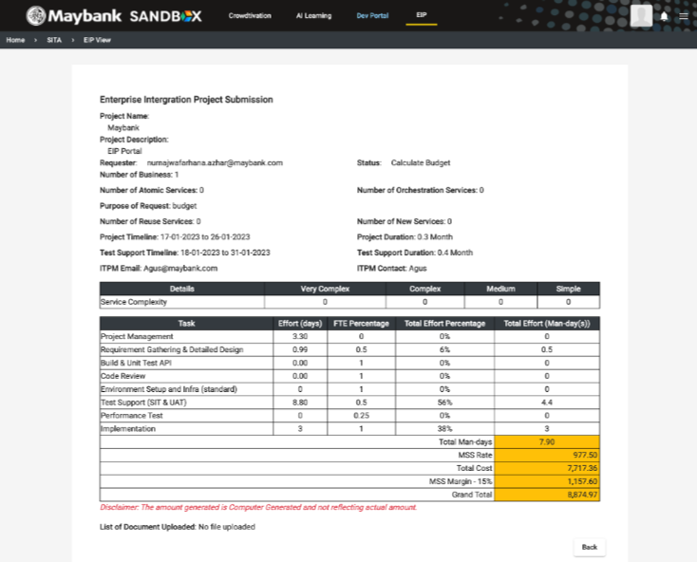

1. If the request been rejected, it will direct back to the submission page (image in number 3)

Compare with EIP landing page for internal and external, external has less access than internal EIP. But, users can access to same API project submission page to input necessary details.

There are 2 conditions:

Condition 1: purpose of request -> budget

Users can proceed with the same steps from step 3 as EIP landing page for EIP team.

Condition 2: purpose of request -> implementation

user need to fill up the details and submit. Once API request is sent, the requestor able to view the status of request by clicking the ‘view’ button. (End of requestor flow)

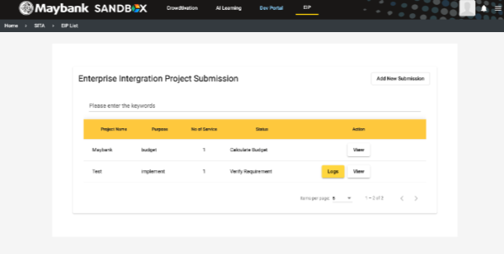

Test script

EIP Landing page for EIP Team (Users are able to approve or reject request)

Users login to Maybank Sandbox

Click on EIP section and reach EIP landing page

Then, click on API Project list

Click ‘add new submission’

Key in all the details needed with \* and submit for approval

Click view to check your request

If the request is pending approval or was approved by EIP team, user is able to view the request

If the request was rejected by EIP team, the requestor will back to project submission page to resubmit.

For internal & external EIP landing page (Users are able to submit request for internal and external API)

Users login to Maybank Sandbox

Click on EIP section then click new API request

If user choose option 1: purpose of request -> budget, user will be directed to EIP submission. User need to fill up the details and submit for approval. Users are able to view the request.

If user choose option 2: purpose of request -> implementation, user need to fill up the details and submit. Once API request is sent, the requestor able to view the status of request by clicking the ‘view’ button. (End of requestor flow)